**INDIA’S AGRICULTURAL CROP PRODUCTION ANALYSIS (1997-2021)**

**INTRODUCTION:**

**This report delves into the captivating realm of India’s agricultural cultivation providing a comprehensive visual exploration of key aspects and trends in the agricultural sector.**

**Empathy map**

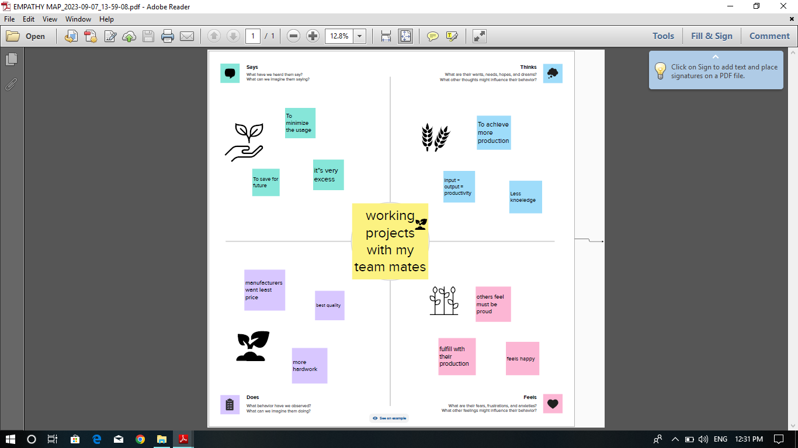

**Brain storm**

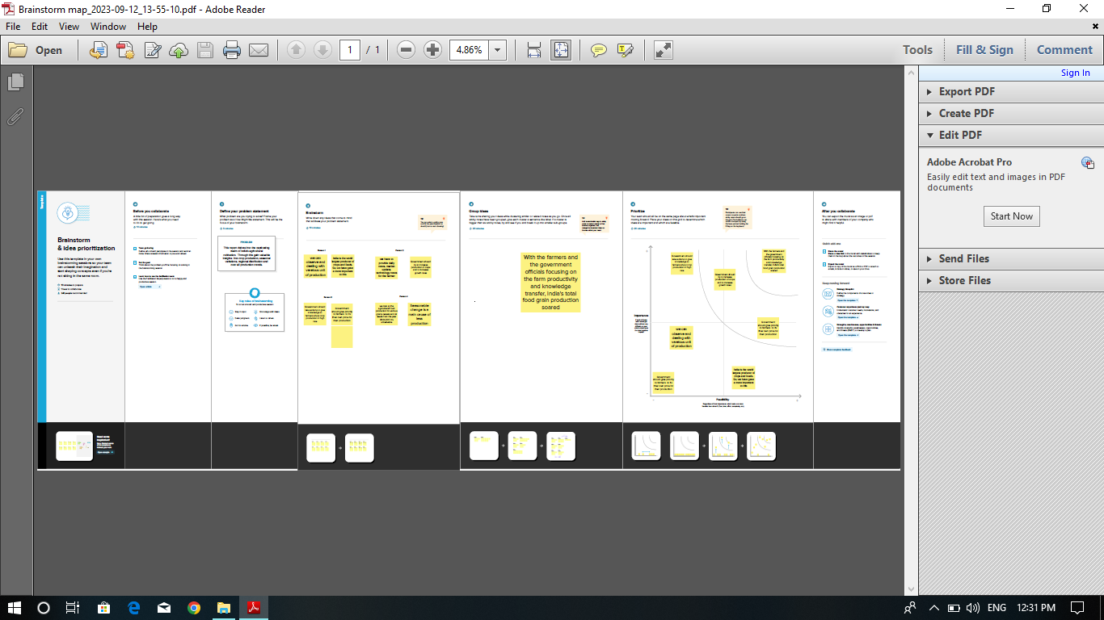

**Tableau desktop**

1. **We have taken a dataset and we analysis the data by using tableau.**
2. **Tableau is the most powerful secure and flexible end to end analytics platform for your data. Elevate people with the power of data.**
3. **Design for the individual, but scaled for the enterprise, tableau is only business intelligence platform that turns you data into insights that drive action.**

**Dashboard**

**A dashboard is a graphical user interface that displays information and data in an organized easy to read format.**

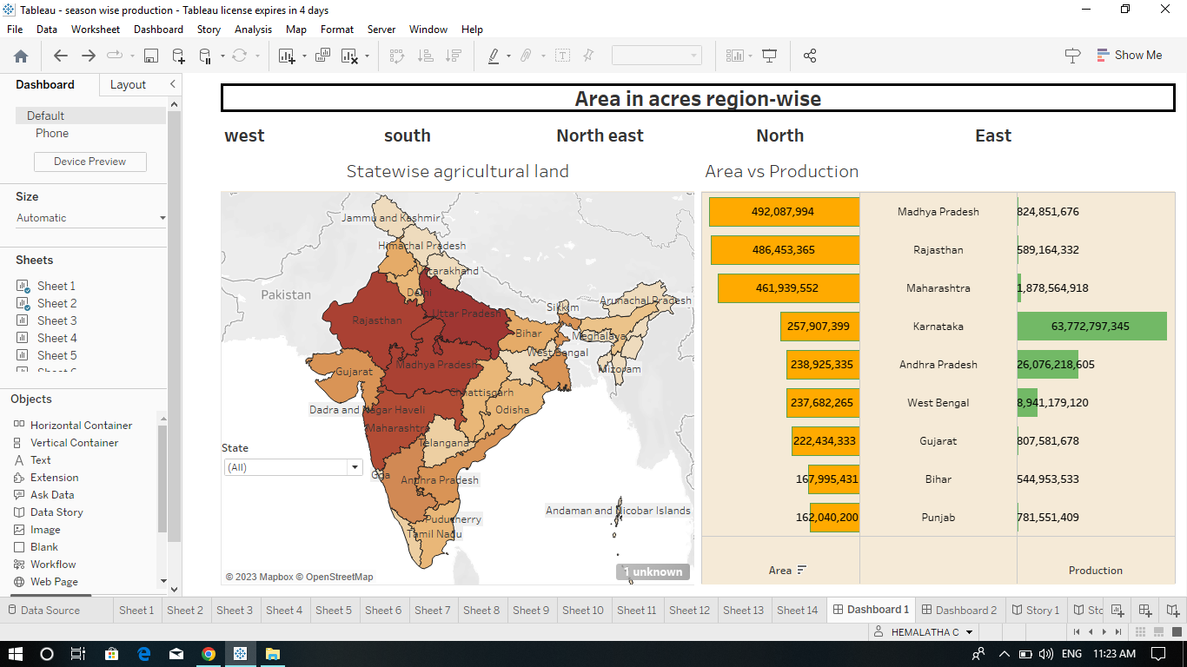

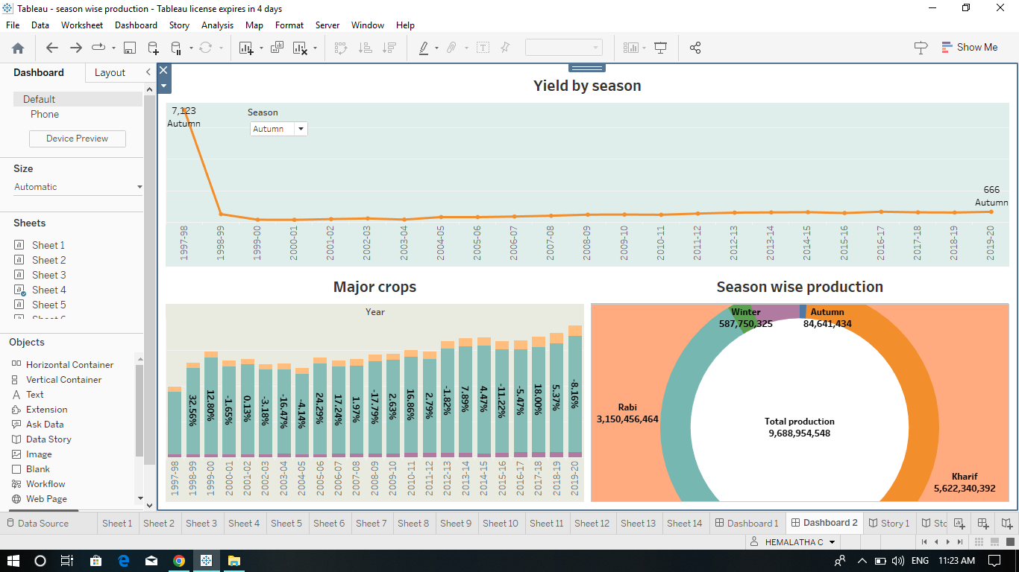**story**

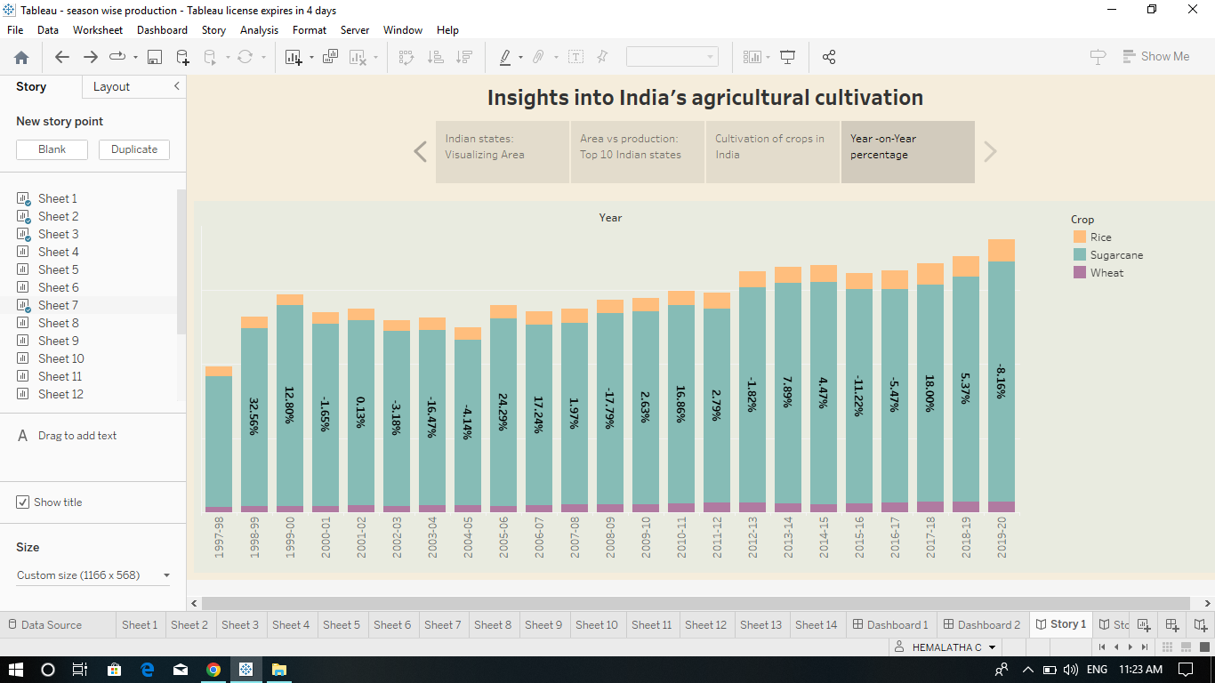 **The report was created.**